Furniture for sale

2 x sofa side tables in glass (0.6 x 0.6 m x 0.5 m)
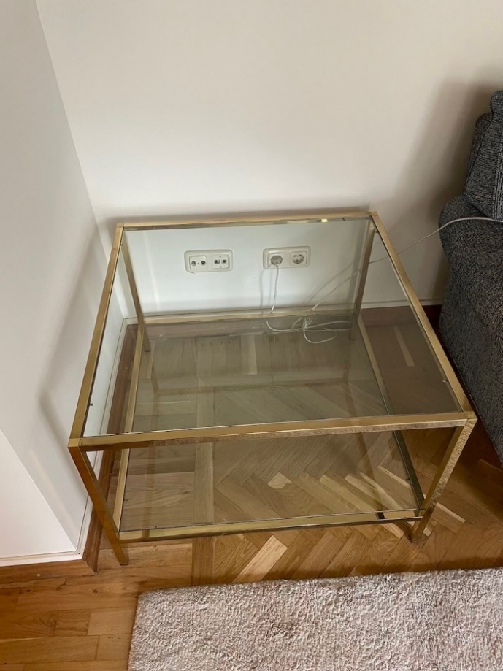

1 square sofa table in glass (1.04 x 1.04 x 0.50 m)
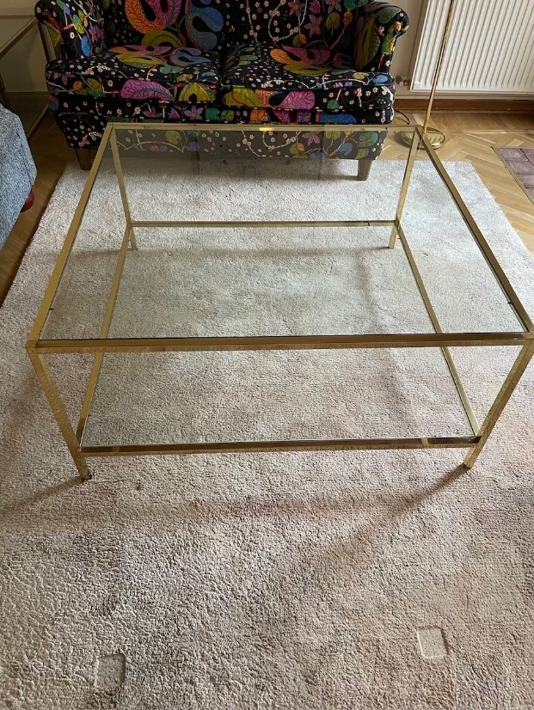
1 rectangular table in glass (slightly damaged) (0,74 x 0,74 x 0,5 m)
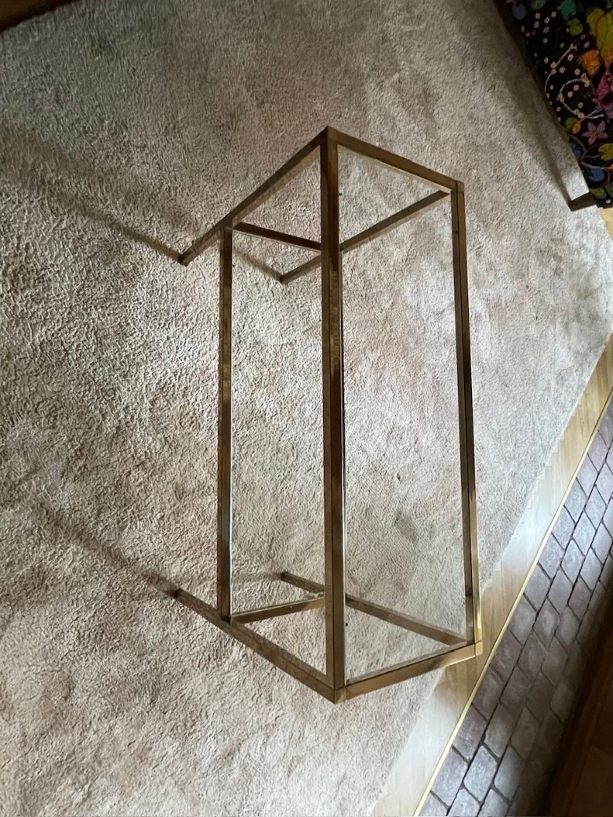

1 IKEA large roof lamp:
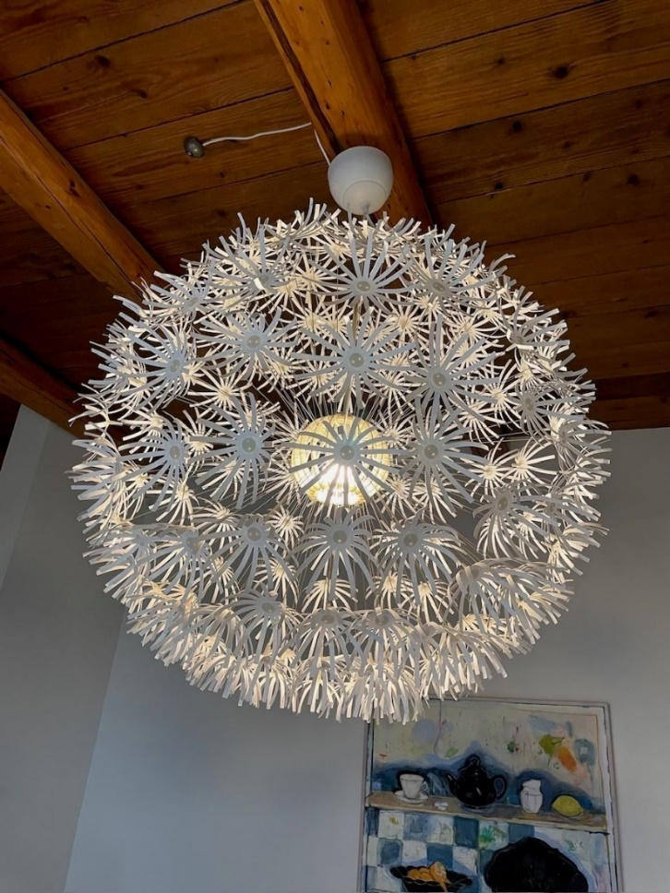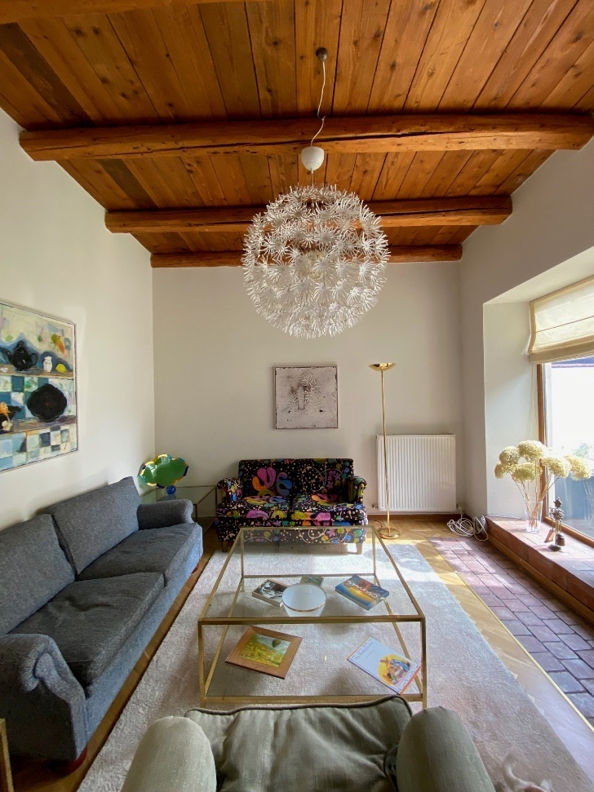
1 floor lamp
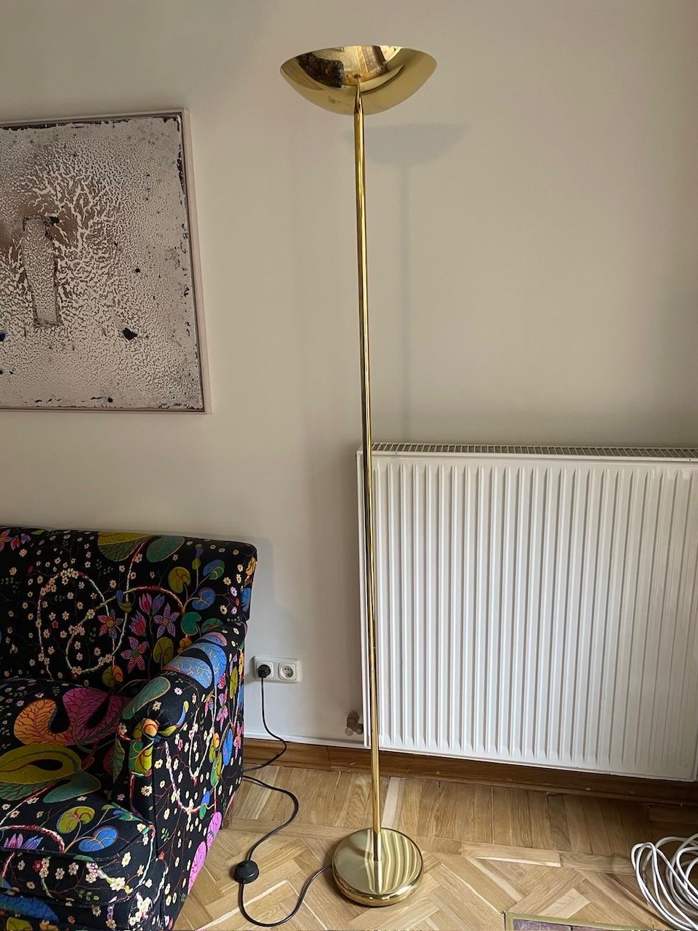

Svenskt Tenn Sofa 2 seats (1.5 x 0.84 x 0.78 m)
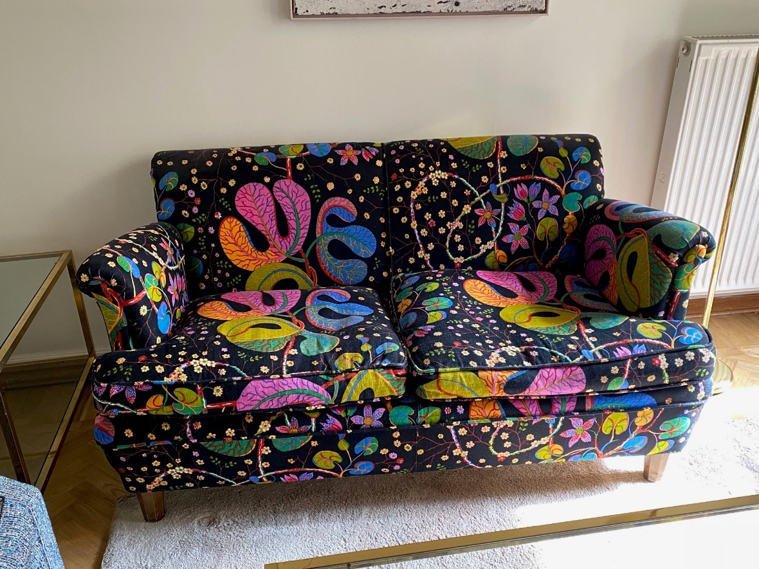
Large carpet (2x4.50 m)
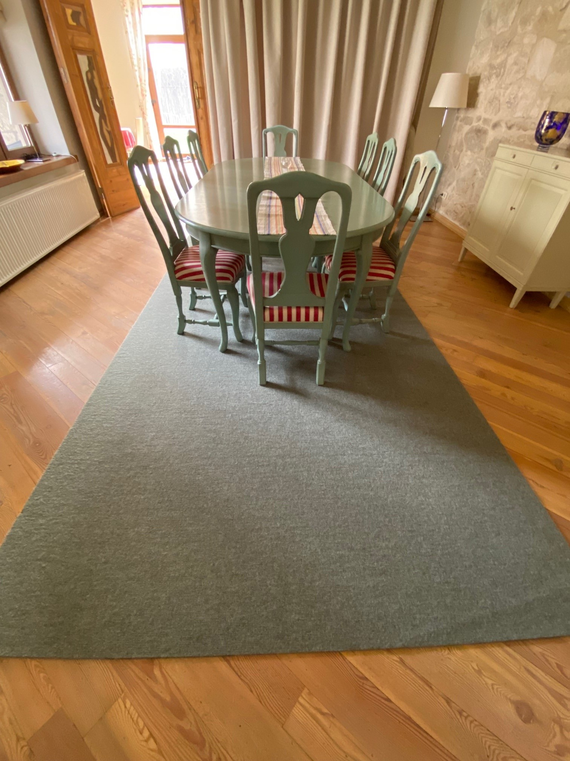

Large carpet (2 x 2.5 m)
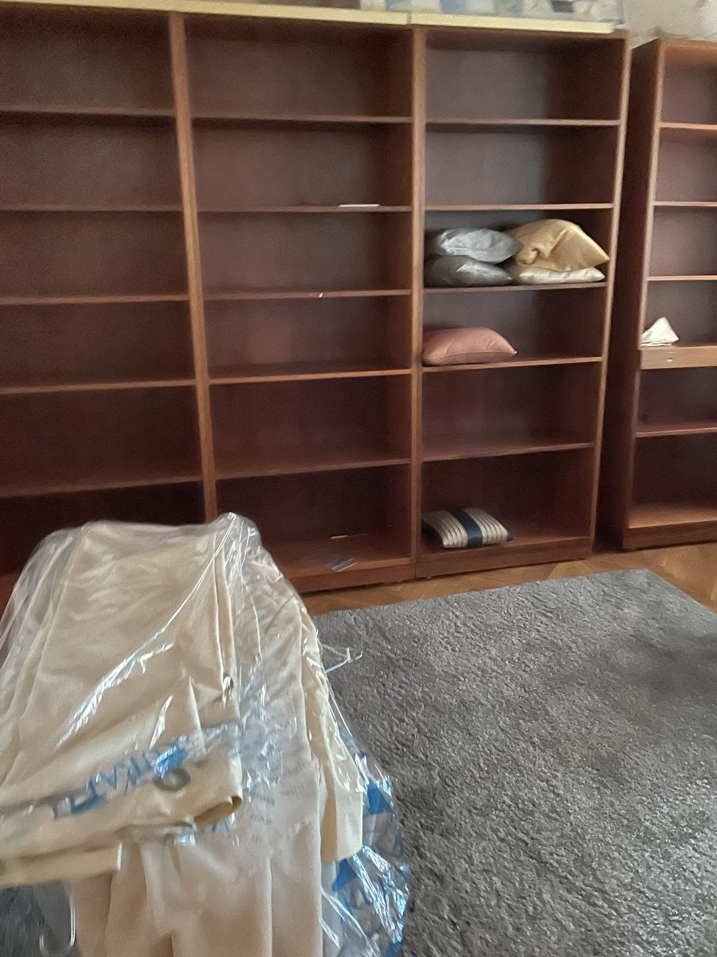

Large carpet (1.60 x 4.50 m)

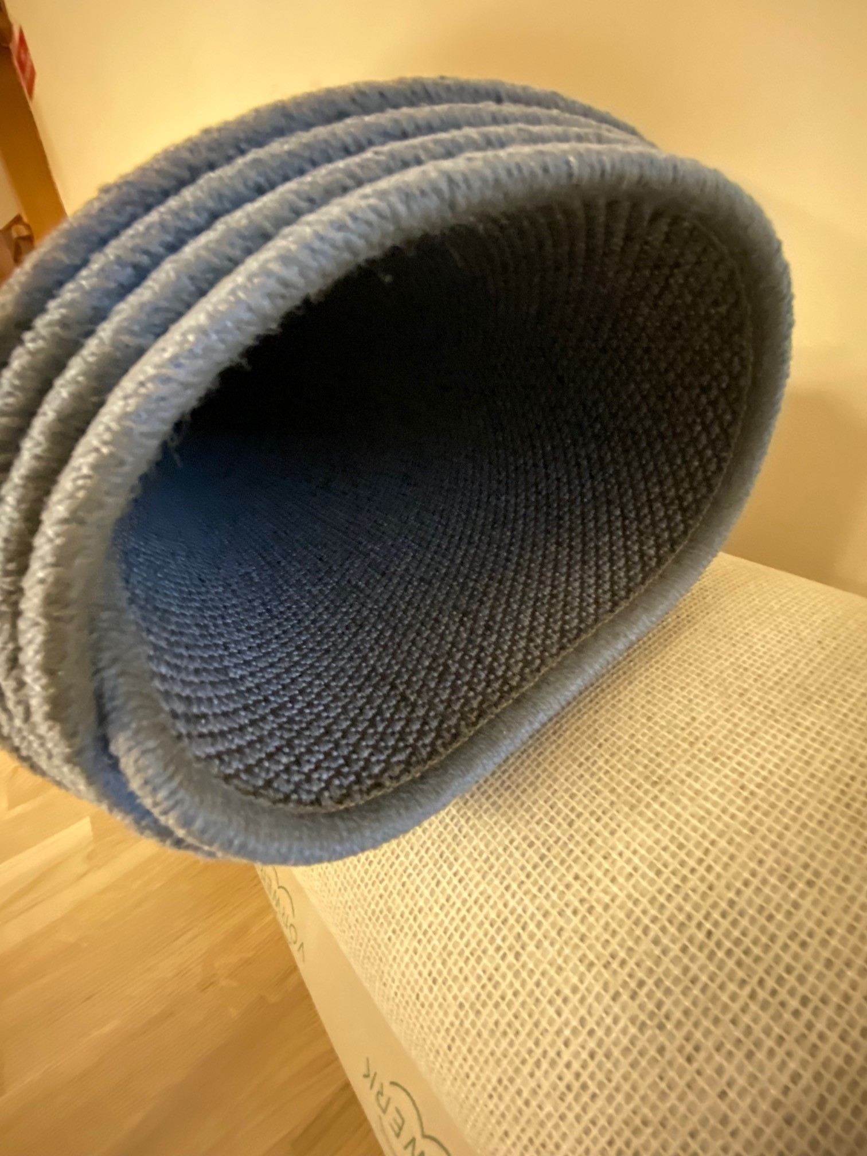
Large carpet (3 x 4 m)
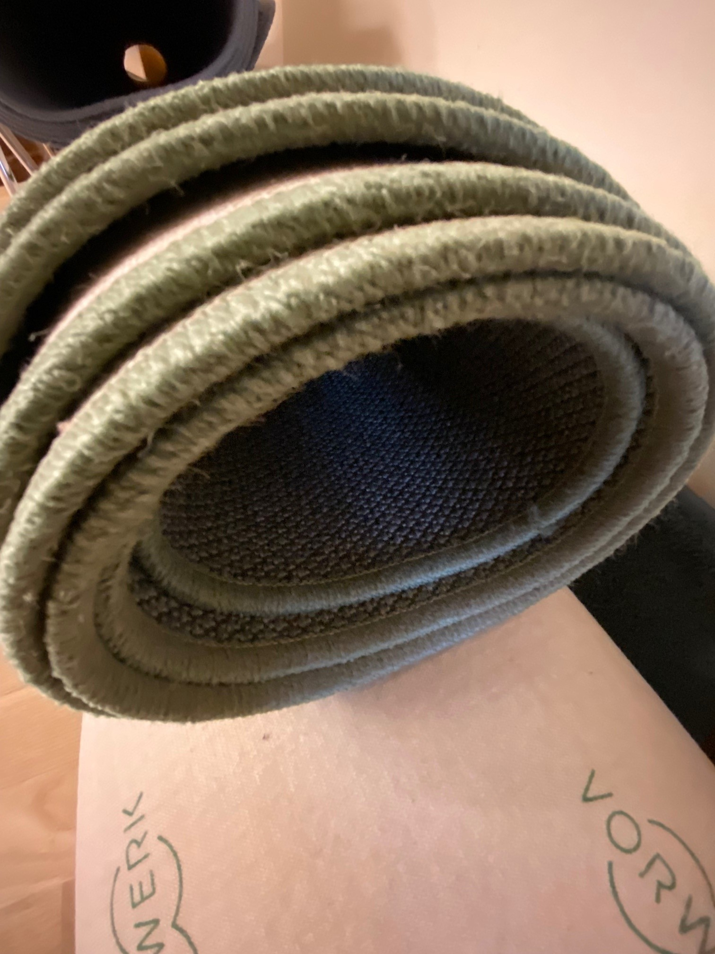
Large carpet (3.2 x 4.5 m)
